**Write a MapReduce program to filter out the invalid records. The output of this program will act as input for subsequent tasks. Map only job will fit for this context.**

**INPUT FILE**

Samsung|Optima|14|Madhya Pradesh|132401|14200

Onida|Lucid|18|Uttar Pradesh|232401|16200

Akai|Decent|16|Kerala|922401|12200

Lava|Attention|20|Assam|454601|24200

Zen|Super|14|Maharashtra|619082|9200

Samsung|Optima|14|Madhya Pradesh|132401|14200

Onida|Lucid|18|Uttar Pradesh|232401|16200

Onida|Decent|14|Uttar Pradesh|232401|16200

Onida|NA|16|Kerala|922401|12200

Lava|Attention|20|Assam|454601|24200

Zen|Super|14|Maharashtra|619082|9200

Samsung|Optima|14|Madhya Pradesh|132401|14200

NA|Lucid|18|Uttar Pradesh|232401|16200

Samsung|Decent|16|Kerala|922401|12200

Lava|Attention|20|Assam|454601|24200

Samsung|Super|14|Maharashtra|619082|9200

Samsung|Super|14|Maharashtra|619082|9200

Samsung|Super|14|Maharashtra|619082|9200

1. **Program(Driver)**

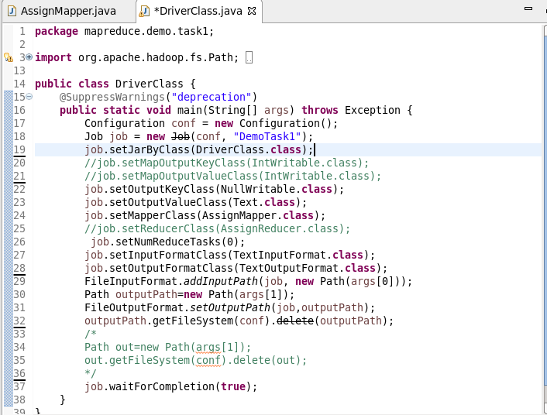

**2)Program(Mapper)**

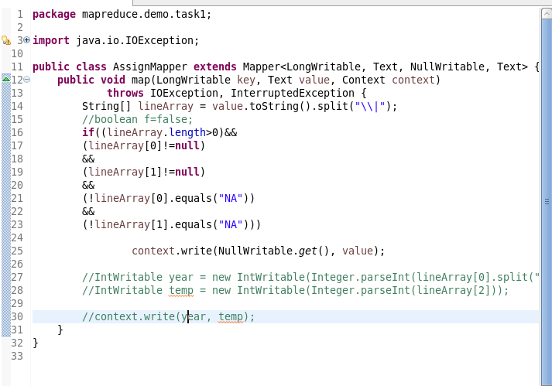

**3)put the input file on hdfs**



**4)run the jar file**



**5)check if the output folder is created**

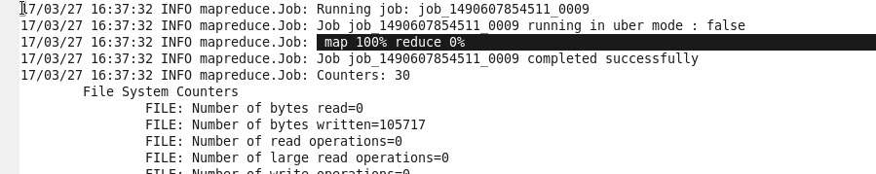

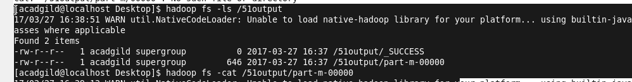

**6)view the contents of the output file**

